**How to upload the Leave Balance using LB Entry**

1. To get to LB Entry, from Dashboard > Attendance Management > Setup > **LB Entry**

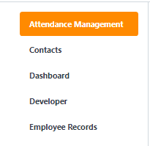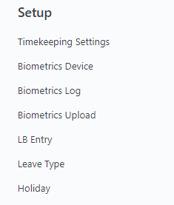

1. 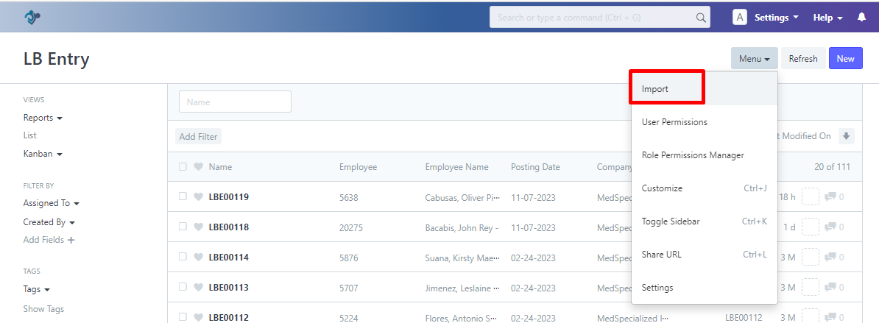Click the **Import**
2. 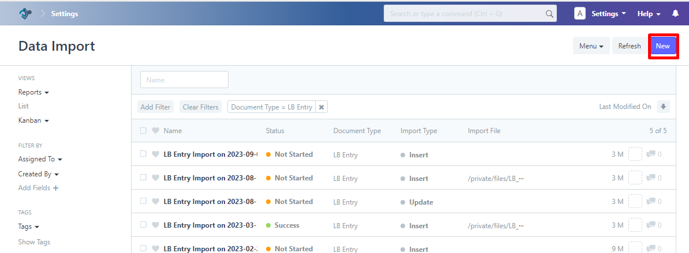Click the **New** Button
3. 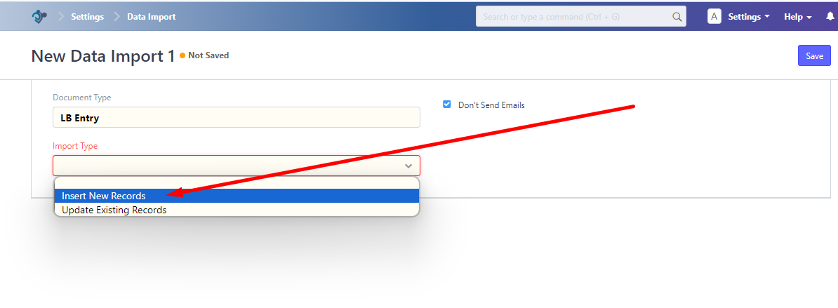Go to **Import type** > Under Import Type > Select **Insert New Records**
4. 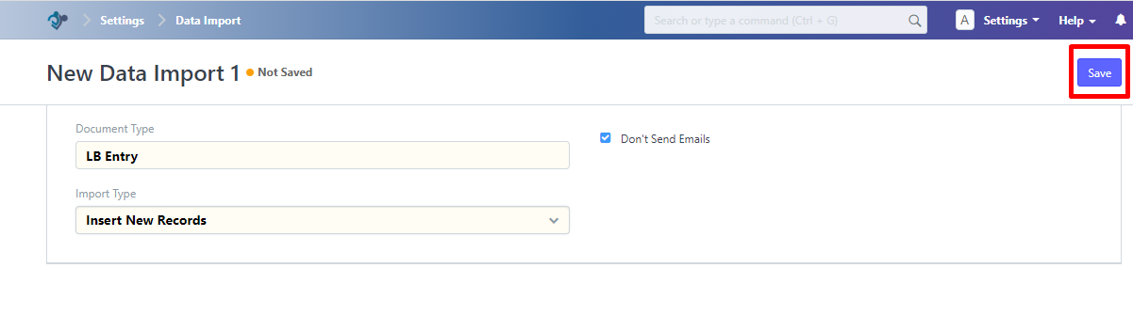Click the **Save** button
5. 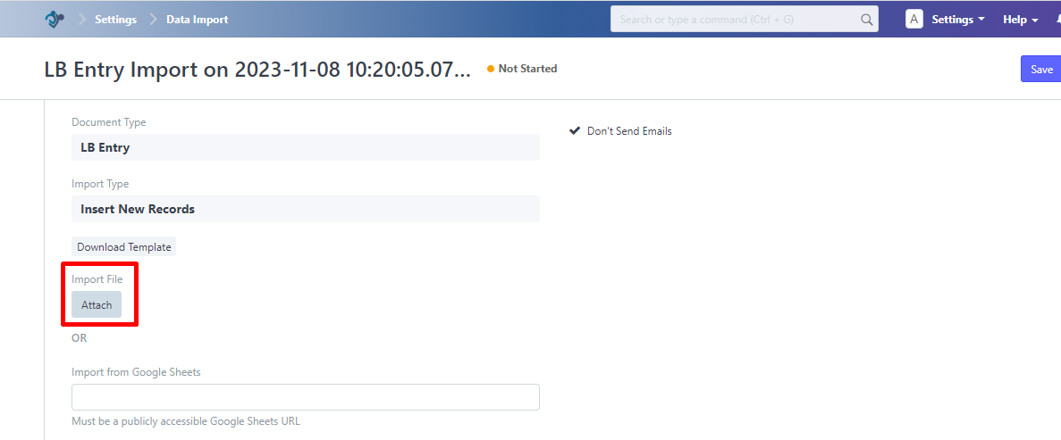Click the **Attach** button
6. 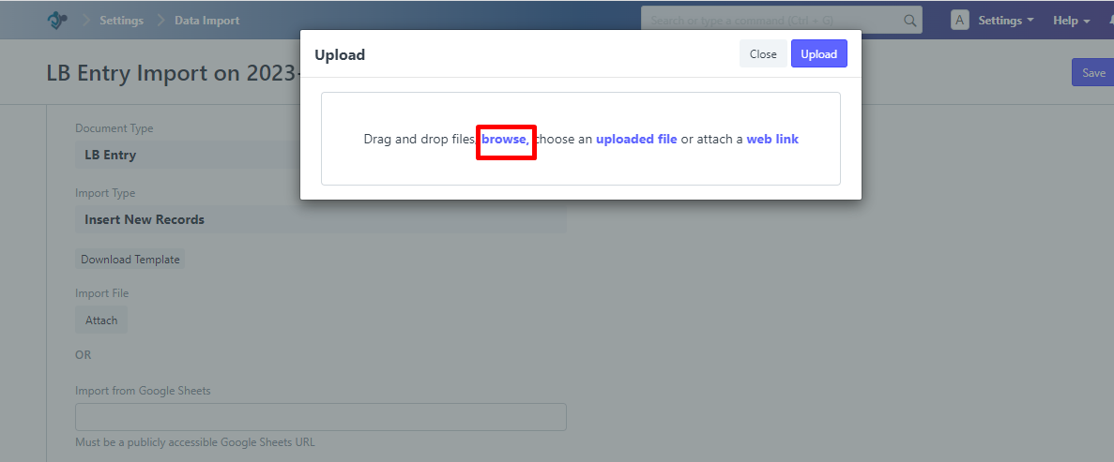Click the **Browse** button
7. And **select the LB entry** template that you want to upload > click the **Open**

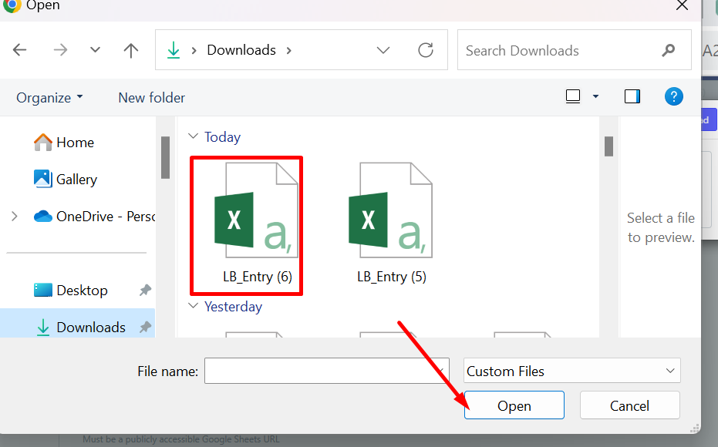

1. 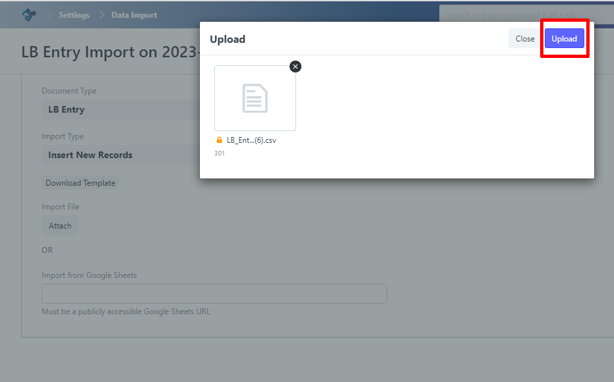Click the **Upload** button
2. Click the **Start Import**

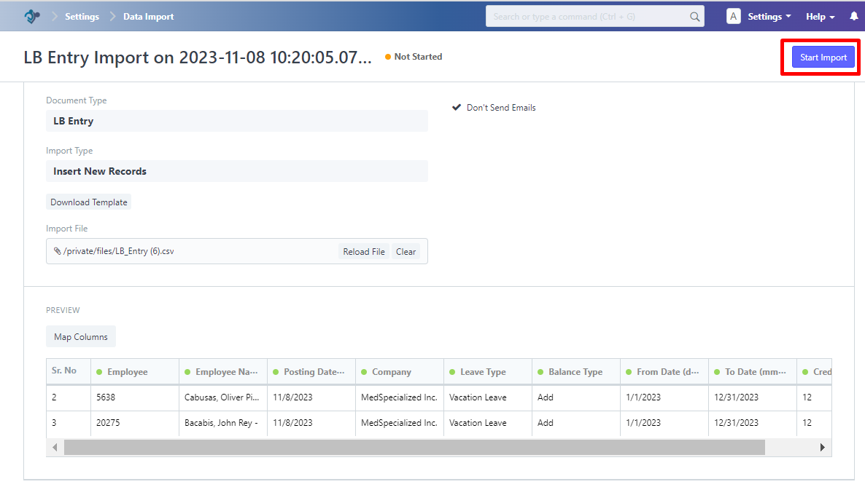

1. 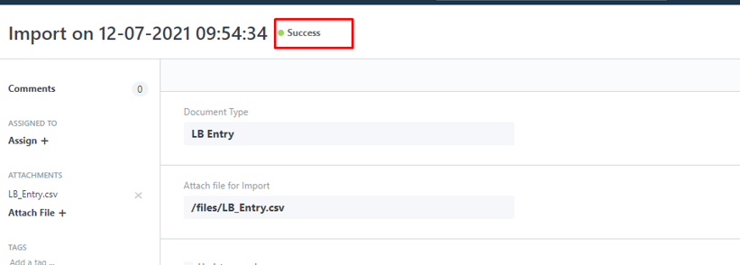 The status displayed should indicate **"Success."**